**MGT562 – Ecosystem Design**

**January 2023**

**Group Based Assignment (GBA)**

|  |
| --- |
| **Members** |
| Sruthi Madhusudanan |
| Mohamed Shammir |
| Danny Tan Zhe Li |
| Koh Yeong Jin Mervyn |

Date of Submission: 18 April 2023

**Company Introduction**

**Background**

Ageing population is a serious issue among most developed countries. By the year 2050, the world’s population of people above 60 will nearly double (Malhotra, et al., 2019). The fertility rate has also decreased to 1.10 per woman in Singapore (Statistics Singapore, n.d.). As the healthcare industry evolved and improved over the years, Singapore’s healthcare industry has kept itself updated with technology and knowledge creating efficient and robust healthcare services. With improved living conditions and healthcare, the average life expectancy of Singaporeans has increased to 84 years leading to the increase in ageing population (Statistics Singapore, n.d.).

With the ageing population increasing the burden of chronic diseases increases which is coupled with new life-prolonging medicines created to treat such diseases (Segar, Ang, Foteff, & Ng, 2021). As such, the need for medical equipment to be easily accessible to the elderly at affordable prices rises. The lifespan of the equipment may also not be fully utilised due to the short usage by the patient. Disposal may pose a problem for such medical equipment as they may be bulky and require payment for professional disposal services (Hinrichs-Krapels, et al., 2022). With such issues, the company decided to focus on how medical equipment can be shared with other patients when its use ends.

The company wanted to work on the following key issues and ensure that no stone is left unturned before embarking on this journey.

* How can we prolong the life of a medical equipment when its need for one patient ends?
* How can we reduce wastage of medical equipment?
* How can we create a platform for one to request for medical equipment and one to donate or sell for a nominal fee a medical equipment?
* How can we assess and score medical equipment based on its condition?
* How can we determine the value of an equipment at different points of its life cycle?
* How can we manage the movement of medical equipment?
* What kind of equipment should not be shared?

The team will address the issues as we share more on the different functions of our company.

**Vision**

The vision of our company – Technology to share equipment for patients.

Our vision at our deep technology venture company is to revolutionise healthcare and the way people live and work by providing innovative technology solutions by harnessing the power of artificial intelligence, machine learning, and advanced data analytics to develop innovative solutions that empower individuals and businesses to reach their full potential while improving patient outcomes and transform the way healthcare equipment is delivered. We envision a world where technology is seamlessly integrated into every aspect of our lives, making tasks simpler, faster, and more efficient.

We believe that healthcare should be accessible, proactive, and patient-centric, and we are committed to connect the patients with second hand or affordable medical equipment, provide more effective treatments, and deliver better patient care. Our focus is on providing personalised solutions that cater to the unique needs of each individual or business.

We aspire to be a global leader in the tech industry, constantly pushing the boundaries of what is possible and pioneering new technologies that change the world. We are dedicated to developing solutions that address the most pressing medical challenges, cost. Our goal is to use technology to unlock new accessibilities that improve the lives of patients.

We value collaboration and partnership, and we will work closely with leading academic institutions, healthcare providers, and industry experts to ensure that our solutions are aligned with the needs of the healthcare community. We are passionate about innovation, and we are committed to pushing the boundaries of what is possible to create a better future for all through the power of connecting the dots. We value creativity, collaboration, and innovation, and we believe that by working together, we can achieve great things.

Our goal is to create a better future for all through the power of technology, and we are committed to making that vision a reality.

**Mission**

The mission of our company – To connect people with needs to people with medical equipment.

We are dedicated to ensuring that medical equipment usage is ethical and sustainable, and we believe that technology has the power to transform the medical equipment industry.

We are committed to collaborating with our partners and clients to understand their unique needs and challenges, and to develop solutions that help them achieve their needs. We believe that innovation is a collaborative process, and we value open communication and partnership as we work to connect people with needs to people with unused quality medical equipment.

Our mission is to make a positive impact on the world through the power of technology and sharing for a better future for patients, healthcare providers, and communities around the world.

**Founders / Management**

The founders of the company and their roles are as stated.

**CEO - Miss Sruthi Madhusudanan**

Miss Sruthi is responsible for providing overall leadership, vision, strategy, and networking of the business. As the CEO, she sets the vision and mission of the company. She plays a critical role in the company to ensure success through various development stages while steering the company to adapt to market changes. She is also the lead strategist for the growth of the company while ensuring that all employees understand and align with the goals of the company.

She is the lead to build and manage the core team by hiring talents to suit the various business functions. She will also be the lead for fundraising and financing of the company. Miss Sruthi has the key role of securing the funding required for the startup and to seek constant financing for operations. Along with fundraising and financing, she also needs to build partnerships and relationships. These relationships are crucial to maintain a constant pool of stakeholders, investors, and partners.

Miss Sruthi is also the key player for the marketing and sales strategy as the company is a startup. She will help the company reach its target market and once penetrated, to achieve growth. She will also need to manage operations initially such as day-to-day business operations, product development, customer support and service recovery. Last but not the least, she will need to identify and manage potential risks that may damper growth or hinder business operations.

**Deputy CEO - Mr Mervyn Koh Yeong Jin**

The Deputy CEO’s main role is to support the CEO in all aspects of the company. The DCEO may be required to step up and lead at various intervals and for various functions to ensure proper leadership and processes. The DCEO may take on the role of executing operational functions with the employees while the CEO is building relationships and partnerships.

**Chief Finance Officer (CFO)- Mr Tan Zhe Li Danny**

As the CFO, Mr Danny Tan is in-charge of all financial matters of the business. He is critical in ensuring the financial health and success of the company by navigating complex financial challenges and opportunities. He will provide strategic financial guidance and governance for the leadership and employees. The CFO will play a key role in financial planning and analysis by creating and managing the budget and giving key insights to support decision making by the leaders.

The CFO is also crucial for securing funding through various channels such as investments and loans. He will also need to give detailed financial reports on crucial aspects such as the company’s financial position, balance sheets, income statements and cash flow statements. As finance matters are sensitive and come with huge risks, he will also need to do risk management tasks such as identifying and managing financial risks, oversee financial controls and implement risk management strategies.

Lastly the CFO will need to manage financial operations and provide strategic financial guidance. Financial operations include tasks such as managing accounts payable and receivable, payroll, and business transactions while strategic financial guidance requires guiding the company’s growth, expansion, and success.

**Chief Operating Officer (COO) - Mr Mohamed Shammir s/o Thirunauc Karasu**

Mr Shammir will be responsible for overseeing the smooth and efficient operations of the company and ensure that the tasks, strategic goals, and plans are executed on a daily basis. He must clearly communicate the operation plans and have good organisational and problem-solving skills. He will implement the company’s strategy through the various teams executing their individual tasks for a common goal.

The COO’s operation scope involves product development, sales, marketing, and customer support. He will need to ensure operational efficiency and reduce costs, improve output, and optimise workflows. He is also key in managing the company’s resources such as the employees, technology, capital, and physical space. It includes building and managing teams and setting performance goals while providing feedback and coaching.

Lastly, he will play an important role in risk management for matters related to regulations, legal and business.

**Business Opportunity**

**Problem Definition**

Healthcare industry remains one of the most important and critical sectors in any society. Medical equipment, which is crucial for patients to receive high quality health care, faces a significant problem in the industry in the form of proper management of medical equipment. This raises several ethical, financial, and environmental issues. Healthcare sector faces numerous challenges with medical equipment management. Some of which includes sustainability, resource efficiency and wastage. On top of it, medical equipment is expensive, and their procurement can leave a big hole in the pockets of both patients & healthcare providers. Moreover, the improper disposal of medical equipment poses environmental concerns, as it leads to healthcare waste generation, which is estimated to be around 5.9 million tons per year, according to the National Library of Medicine.

Lack of proper maintenance and repair services is another significant problem in the healthcare industry. WHO reports that 70% of medical equipment in low-resource settings is not functional and most of them are discarded due to a lack of repair services. A study published in the Journal of the American Medical Association reports that medical equipment utilization rates in hospitals is as low as 25%, meaning that a significant amount of equipment is sitting idle and unused. These issues highlight the need for more efficient and effective medical equipment management in the healthcare industry.

One of the solutions that we could consider is to implement equipment sharing programs. These programs can result in significant cost savings. This is seconded by a study published in the Journal of Clinical Engineering, which reported that equipment sharing programs in hospitals can result in significant cost savings. National Academy of Medicine has suggested that improving the reuse of medical equipment could help reduce healthcare costs and improve sustainability, while also increasing access to healthcare in low-resource settings.

Ours is a deep technology venture that aims to revolutionize healthcare and promote sustainability. Our platform leverages advanced technology solutions such as artificial intelligence, machine learning, and data analytics for medical equipment management. Our goal is to create solutions that empower both patients and healthcare professionals by transforming the way medical equipment is shared. Presently, when a patient or healthcare practitioner no longer needs a piece of medical equipment, it is frequently disposed of or sold at a loss. As a result, there is substantial resource waste and ineffective usage. We aim to address these issues via our platform. Our platform will facilitate patient-to-patient and hospital-to-patient equipment sharing, allowing individuals and businesses to donate or sell medical equipment for a nominal fee. This in turn helps in efficient use of resources and reducing wastage. To guarantee that only top-notch equipment is available for usage, the platform will also evaluate and rate the state of the equipment.

Medical equipment is often disposed of prematurely due to poor maintenance. Machine learning algorithms can be used to assess and score medical equipment based on usage history, maintenance records, age, and other factors thereby enabling end users to make informed decisions about equipment maintenance and disposal. A survey on machine learning-based techniques suggests that machine learning-based techniques can detect equipment faults at an accuracy of 99.73%. Analytics can also determine the value of medical equipment at different points in its life cycle and help identify the best time to replace equipment based on utilization and depreciation. Efficient management of the movement of medical equipment and determining which types of medical equipment are suitable for sharing and which are not is essential to minimize the risk of injury to patients and reduce wastage.

In summary, our mission is to connect people with needs to people with medical equipment while promoting sustainability and responsible sharing of equipment. Our platform can help reduce wastage, assess, and score medical equipment, determine its value at different stages of its life cycle, manage the movement of equipment, and ensure that only suitable equipment is shared. We believe that by harnessing the power of machine learning, analytics, and sustainability, we can revolutionize the healthcare industry and improve patient outcomes around the world.

**Market Size**

The market size for second hand medical equipment is endless provided it is managed properly. For example, the hospital bed market is expected to grow up to 6 billion dollars in India between the years 2023 and 2032 as more hospitals are trying to upsize and provide higher quality of care and comfort to their patients (Rajendra Singh, 2023). As hospitals switch old beds to new beds, the older beds will be able to be circulated for home care patients at a fraction of the price and potentially bring some pocket change for the hospitals.

As for Latin America, the home healthcare market is expected to be worth 37.15 billion by 2030 as countries such as Brazil, Mexico, Argentina, Columbia, and Chile have the largest population of elderly population in the whole region. In Brazil alone, the number of citizens above the age of 60 is expected to reach 50 million by 2030. The medical equipment market is expected to generate the largest proportion of revenue in the year 2023 (Meticulous Research, 2023). In relation to the rest of the world, this shows the potential of the second-hand market for used medical goods as most people in these regions are unable to afford brand new equipment.

Another study found that in the United States of America (USA), medical equipment that are in good working conditions are often disposed by healthcare facilities. This ‘trash’ is estimated to cost 765 billion dollars a year. It includes expensive equipment such as ultrasound machines, infant warmer, uterine dilators, ventilators and even forceps. The key reason for such a huge number of disposed equipment is the constant introduction of new and upgraded machinery (Mirza, 2017).

In the context of remarkable individuals who have taken into utilising second hard medical equipment for charity is one mother who started collecting medical supplies after her disabled son outgrew his equipment. She gives away collected medical equipment for free and boasts having 50 hospital beds and 1000 crutches (Hintze, 2020). This shows that people do donate to clear rather than throw their used medical equipment once they no longer have use for it.

People also face a lot of difficulty to clear such medical equipment. Another mother from Dallas wanted to donate her son’s medical equipment once he passed away. She managed to find an organisation that was willing to take her equipment about 2000 kilometres away. The equipment consists of items such as car seats and standing chairs. There were also a lot of costs involved in collecting and storing large medical equipment and it was taxing to connect people with needs with people with equipment (STENGLE, 2022).

Locally, the aging population in Singapore is expected to reach about 1 in 4 Singaporeans to be aged 65 years old and above (Tan, 2022) by the year 2030. A report from Deloitte Consulting (2019) predicts that the silver generation of Singapore will contribute spending of nearly US$149 billion by 2030. Specifically, 9% (approx. US$ 13.5 billion) of that spending would be on health and health-related goods/services.

As an example, currently, electric patient beds in Singapore are rented out at $50 a month or purchased at $1580. These beds are modular and can be packed into flat packages. As the buying power of Singaporeans are generally higher, most family members buy new beds rather than rent beds (Ng, 2015). If these people are selling their beds in the second-hand market after their need for the bed finishes, we may have affordable beds for other patients.

The above shows that there is a significant market size both in Singapore and overseas. With the industry worth billions of dollars, a potential breakthrough is possible. With the appropriate marketing, conditions and platform used, we may be able to grow and connect buyers with sellers and value add by introducing various new schemes such as sanitation, equipment testing, shipping and maintenance.

For the initial state of the business, it is intended for the business to adopt a B2C and C2C model, with a focus primarily on the local market of Singapore and selected regions of the USA as well as India, where sufficient demand volume resides (given its potential size).

**Competitive Analysis**

Let's take a few competitors in the medical equipment sharing space and compare how we will differentiate from them.

**Direct Competitors**

**Cohealo**:

Cohealo is a medical equipment sharing platform that connects hospitals and medical facilities with available equipment. It offers features such as equipment utilization tracking, asset sharing, and equipment pooling. Cohealo's platform enables healthcare providers to identify and share equipment that is not being used, improving efficiency, and reducing equipment costs.

**MedXchange**:

MedXchange is a medical equipment rental platform that allows healthcare providers to rent medical equipment from other providers. It offers a wide range of equipment such as imaging, laboratory, and diagnostic equipment, as well as surgical instruments and devices. MedXchange's platform enables healthcare providers to rent equipment at a lower cost than purchasing new equipment.

**GoShare Healthcare:**

GoShare Healthcare is a medical equipment sharing platform that connects healthcare facilities and providers with available medical equipment. Similar to Cohealo, it offers features such as asset sharing, equipment pooling, and utilization tracking. However, GoShare also offers a platform for sharing and scheduling medical personnel such as nurses and doctors, in addition to medical equipment.

**Bimedis:**

Bimedis is a B2B marketplace for new and used medical equipment. It connects B2B suppliers and manufacturers with an online platform that provides listing visibility to medical equipment for sale. As part of its financial strategy, Bimedis provides tiered accounts that free or paid. Pro accounts provide sellers with added privileges, such as listings on the sellers’ catalogue page, while premium accounts are provided advertising services from Bimedis itself. In addition, paid accounts are provided with a “Trust Mark” that can be earned, to verify the legitimacy of the seller.

Indirect Competitors

**e-Commerce Platforms**

While not specifically direct competitors dealing with the sales of medical equipment, e-Commerce platforms such as Carousell, eBay, Lazada, etc, do provide businesses and consumers alike, a large active user base within a conducive platform to buy/sell goods online. These platforms generally also do provide doorstep delivery services through partnerships with third-party service providers.

**Online Community Groups & Forums**

Another group of indirect competitors would be community platforms and forums such as, Facebook Groups and Craigslist. While these are fundamentally not operated as businesses, they can potentially act as an informal connector between buyers and sellers. An example of such practices already in place can be seen on Facebook Group, “Caregivers for Elderly”, whereby community members openly post basic medical equipment such as, medical plasters, adult diapers, shower chairs, commodes, wheelchairs, and electrical beds for selling and/or giveaway (Facebook, n.d.).

**How we differ:**

Our platform differentiates itself from our competitors in several ways.

* First, most of the competitors don't offer patient-to-patient, hospital-to-patient or patient-to-hospital equipment sharing whereas we will be offering those. Our platform promotes sustainability by enabling patient-to-patient and hospital-to-patient equipment sharing, reducing wastage, and promoting resource efficiency.
* Our platform uses advanced technology such as machine learning and data analytics to assess and score equipment based on usage history, maintenance records, age, and other factors. This feature ensures that only top-quality equipment is shared on the platform, promoting patient safety, and reducing equipment downtime.
* Our platform offers a system for tracking and managing equipment movement and inventory, ensuring that healthcare providers can manage their equipment effectively.
* Our platform aims to provide a comprehensive inventory of medical equipment, including a wider range of specialized equipment for different medical specialties. This allows healthcare providers / patients to find the exact equipment they need for their patients.
* Our platform aims to offer a flexible pricing model that includes short-term and long-term rentals, providing flexibility to the end users on the financing.
* Our platform will provide insurance coverage on transactions to protect both the buyer and seller.
* To strengthen our value proposition, we will provide sterilising and refurbishment services to our users.
* With the push to go beyond primary care into preventive care and the need for greater involvement from community partners in Singapore (Medina, 2022), we can potentially expand our platform’s services aside to buy/sell services, to also serve as a platform to get community partners to connect and engage. This can potentially support the nation’s push for health activities such as free programmes to keep fit (Tan, 2022).

**SWOT Analysis**

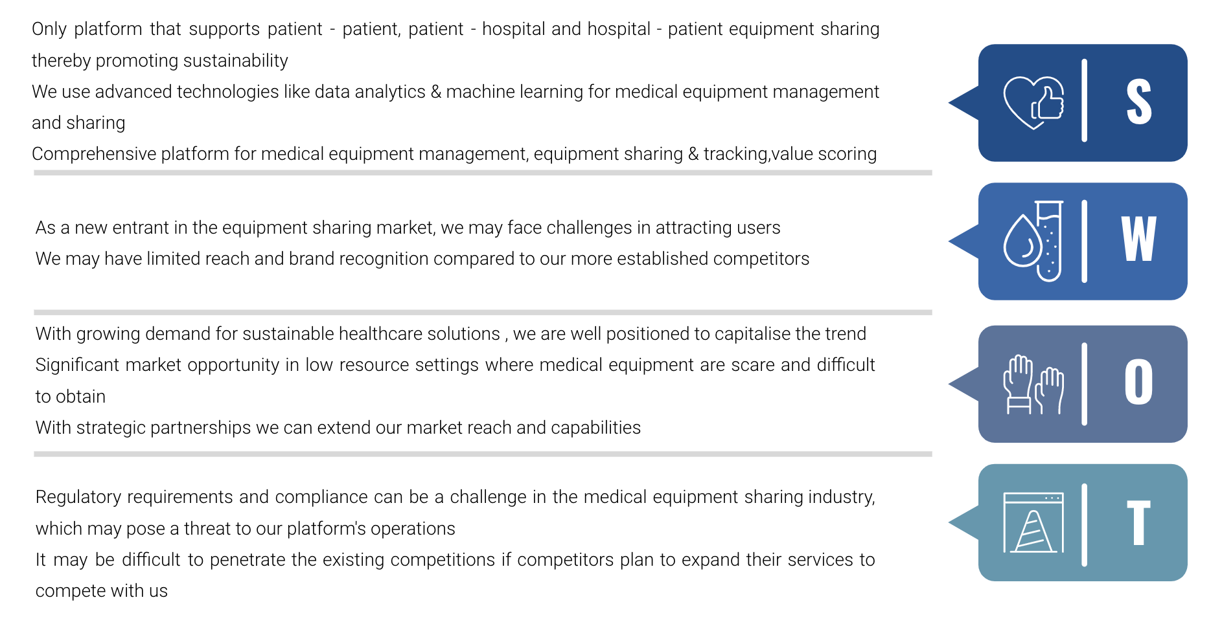

**Product and Technology**

**Minimal viable product**

Simple illustration to MVP, excluding complementary services -

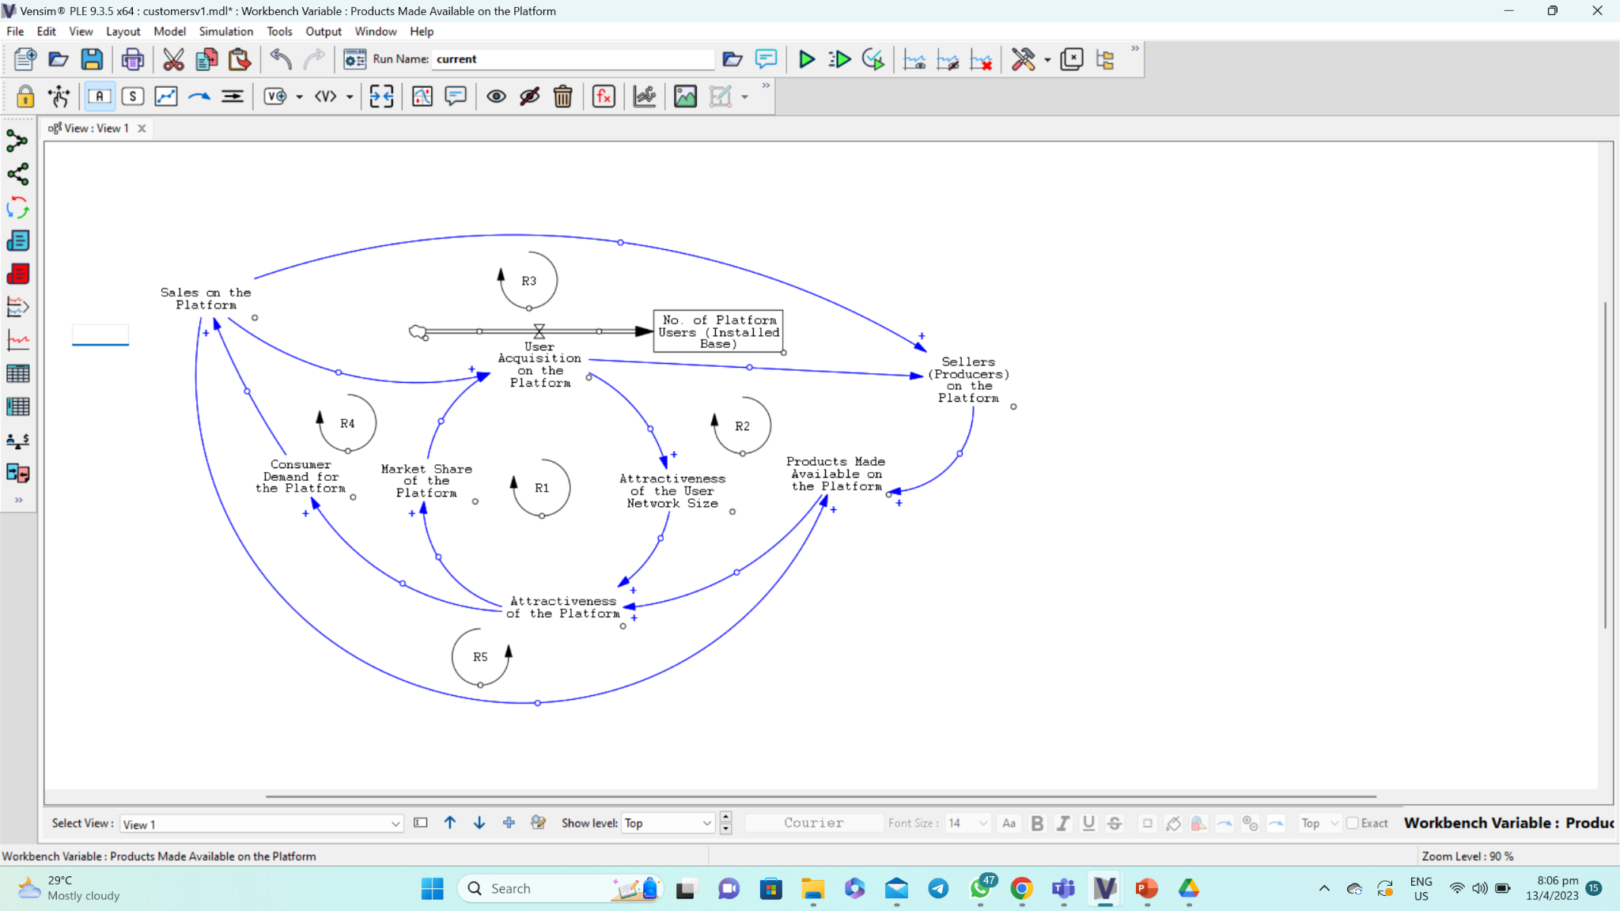

In facilitating the development of a platform-based business, we will adopt the key principles of platform design and focus on the exchange of information, goods/services, as well as currency transaction (given that the platform is intended to be used globally in the future).

The platform will be a mobile-based application on both IOS and Android, with an additional variant that is on the web-based. It will have three primary users who are the sellers, buyers, and administrators. The sellers are the ones that will create value by providing and listing products for sale on the platform, while the buyers would be the ones that consume this value by purchasing products listed on the platform. Users will be able to post listings, browse items for sale or free and eventually communicate with one another to coordinate transactions which consist of handing over, taking over and payments if any.

The following are the processes required for the MVP. User registration, user functions such as browsing, listing, filtering, and searching functions, and communication platform.

User registration will be required for all users before utilising the product. They will allow users to register and create accounts using various ways such as Facebook, Google Account, e-mail and Singpass. After which, the missing details will need to be inserted. Users should be able to manage their profiles, accounts, preferences, listings, and transaction history.

User functions will allow users to list their approved medical items for sale under the different categories. Categories will be like breathing apparatus, beddings etc. Users should also be able to browse items that have been listed by other users and supported by other functions such as category, price, location etc. To be more detailed, the platform should have search and filtering options to give users easy accessibility.

It is important to have a proper communication platform for users to communicate with one another to perform transactions. As such, the product will need to have instant messaging and notification features. To keep communication transparent, users can also amend and post the final buying and selling price after any negotiations.

To further strengthen the governance and control of listed products on the platform, we will leverage on user feedback and review of products on the platform, for users to rate buyer/seller transactions. This to be framed against the quality of the product sold and the purchase/selling experience.

Administrators will need to be able to amend, delete and communicate with users if any items are not in usable conditions. Administrators will also need to be able to restrict and limit users who may breach any conditions listed. Additionally, there will be included a reporting function for users to report suspicious account behaviours on the platform to the administrators.

In further creating value for users of the platform, we will adopt best practices, such as providing insurance policies to both parties in the transaction on the platform (Hagiu and Rothman, 2016). We will partner with payment security and gateway services (e.g., Stripe, Atome) to facilitate financial transactions on the platform for ease of platform use. At the initial state of the business, we will also provide incentives for users to onboard the platform by offering complementary services on sterilisation and refurbishment of medical equipment at cost recovery prices, for the purposes leveraging the network effect to grow the installed base to reach critical mass. The sterilisation and refurbishment business shall be run by a separate business entity set up. As part of the MVP, we will also partner with delivery companies (e.g., NinjaVan in Singapore and Indonesia) to provide delivery services for the goods sold.

Eventually, it is intended that the business model will morph to cover additional features apart from operating as a mere marketplace (e.g., Shopee), to include experts’ opinion (e.g., WedMD), build social connections/community (e.g., Facebook Groups), as well as gamification to earn discount rates for purchase in order to encourage recurring user usage of the platform. To take things further at a much later stage, we will consider diving into the self-provision of e-wallets and financing solutions on the platform, thereby transforming the business to operate as a financial institution as well.

**Product Architecture**

To support the growth of the installed base without disruption to the overall availability, reliability, and performance of the platform, the system shall adopt a scalable architecture that is loosely coupled without too many dependencies (Concepta, n.d.), so that enhancements can be progressively made to the platform and its features without affecting the entire operations of the platform. A distributed network using a load balancer can help to manage spikes in traffic to the application. Further, cloud hosting services such as AWS cloud stacks can support easy scaling of infrastructure resources to cope with fluctuations to traffic on the platform (Shawi, 2020). Adopting best practices such as caching of data and information closer to the end-users is crucial to reduce content load times. This could be facilitated using a Content Delivery Network service. In addition, to consider the adoption of a microservices approach to functions and features that are connected through APIs on the platform, which is to be built on the primary operating systems of Apple iOS, Google Android, and Linux/Windows.

Sample illustration to the product/system architecture -

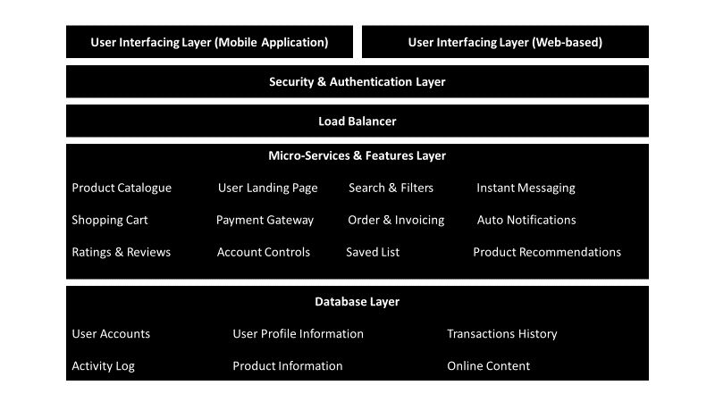

**Product Roadmap**

In facilitating the growth of the installed base, we will adopt a mobile-first approach by prioritising development of the platform on the 2 main mobile operating systems in Singapore (Statcounter, 2023a), USA (Statcounter, 2023b), and India (Statista, 2023).

The initial state of the web-based variant would be simply a landing page to route users to download the application on their mobile devices. This would be subsequently developed into a web-based desktop site once the mobile applications have stabilised in performance.

The illustration of the Technology Roadmap below outlines the development cycle for the MVP -

**Objective of the Roadmap:**

To launch a new B2C/C2C online marketplace platform for the buying and selling of medical equipment.

**Defining the Success:**

The achievement of a mobile-first platform that facilitates individuals to easily onboard, communicate, and buy/sell medical equipment in a simple, secure, and user-friendly way.

**Technology Trends to Adopt:**

Mobile-first design, Cloud Computing, Artificial Intelligence, Micro Services, and Blockchain technology.

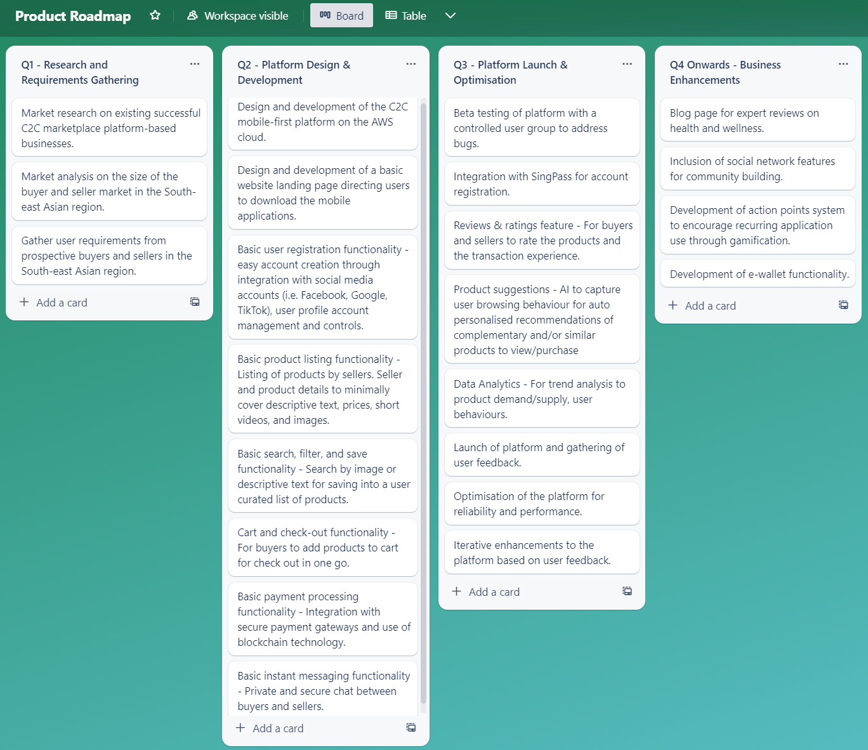

**Strategies & Implementations**

**Stakeholder Analysis**

Stakeholder analysis helps to effectively manage the interest and expectations of stakeholders in the Med Market ecosystem. Stakeholder communications and engagement is key to sustaining the business model. Carlos Carrasco et al. (2022) theorized that digital platforms, like Med Market, could mitigate stakeholder resistance to their operations by including affected stakeholders in an explicit stakeholder value proposition (SVP) in their business model. Since SVP addresses how Med Market adds value or solves problems for target stakeholders, its creation allows Med Market to generate value for all stakeholders, and ultimately ensures long-term wellbeing of the Used/Refurbished Medical Equipment market ecosystem.

As such, we conducted a stakeholder analysis to better understand the needs of each identified stakeholder and their primary requests and requirements. It is important to have a clear understanding of each stakeholder and their expectations, to prevent overlapping interests or wasting duplicating resources with Med Market’s core requirements.

**Producers (Sellers)** - Med Market producers/sellers are typically individuals or businesses that offer used or refurbished medical equipment or devices for sale on the Med Market platform. They may be family or friends with access to these used equipment or they can also be healthcare institutions or healthcare facilities like hospitals, clinics, laboratories etc. They may offer a wide range of equipment that may be suitable for secondary markets on Med Market. Sellers are one of the most important key stakeholder groups in the ecosystem as they provide products that attract buyers to the platform. By creating a supportive environment for sellers, Med Market can help build a vibrant and trusted ecosystem that benefits all stakeholders.

**Consumers (Buyers)** - Buyers may be individuals that purchase medical equipment or services (in later stages) on the Med Market platform. They are a critical stakeholder group as they are the primary source of revenue for the sellers and platform initially. Success of the Med Market platform is dependent on the satisfaction and loyalty of buyers. We must create an environment where it is attractive to buyers, like high quality equipment, competitive pricing, convenience, ease of use, personalized alerts or recommendations of newly listed equipment, easy search etc. In order to enhance buyer experience, Med Market must protect buyers from fraudulent equipment, payment processing mechanism and dispute resolution etc.

**Investors** - Med Market investors provide funding to us to develop, launch, grow and maintain the platform. Resources (Funding, Business Knowledges, Networks, Advice etc) from them allows Med Market to accelerate growth and profitability. Med Market must be transparent and responsive to investor needs and expectations such that investors will continue to fuel innovation, expansion, and long-term sustainability of the platform.

**Partners** - Partners are organizations that are working with Med Market to create value for Producers and Consumers. Partnerships can be developed in many forms within the platform. There could be integration of software or services onto the Med Market, like payment or logistic services. There could be other forms of partnerships like co-marketing efforts, strategic alliances for solution offerings. Successful partnerships can be developed if Med Market can align strategic goals, communicating clearly about expectations and performances, as well as building trust and credibility. It is very important to understand that there must be benefits to partners to continuing to invest in Med Market. By continuing to nurture strong partnerships, Med Market can create a vibrant and thriving ecosystem that will be advantageous to all stakeholders.

In the later phase of Med Market growth, we will have a specific profile of Strategic Alliance Partner Team to develop our partners community. We may develop additional partner solutions and services, which will complement the ecosystem growth.

**Regulators** - Med Market is a platform for exchanging medical devices and equipment. Med Market must therefore comply with industry regulations and standards. We must ensure that the platform is safe and effective for use in the healthcare setting. Med Market should actively engage and seek guidance from the Health Science Authority or Ministry of Health in Singapore, and to regularly review and update the processes to ensure ongoing compliance to medical equipment use.

In the second phase of our Med Market growth, we may need to work with the authorities for further assessment and compliance of our new products listing and services offerings. Maintaining regular cadence is important to the growth of the business.

**Competitors** - They are other platforms offering similar services or products. We had already conducted and explained Med Market’s competitive advantage against our competitors, however, they are still a critical stakeholder group in the platform ecosystem. Competition can help to spur innovation and create new opportunities for growth and differentiation. Med Market must be agile and responsive to advancements and new services provided by competitors. In some instances, too many competitors on a similar industry landscape may lead to market saturation and prize wars, which will erode viability, profitability, and waning customer loyalty.

**Community** - Med Market community refers to producers, consumers, partners, regulators, and other stakeholders who actively participate in the platform ecosystem. Community members are critical to the success of the platform, as they help to shape the direction of the ecosystem and contribute to the growth of the platform. A strong and engaged community creates a cycle of value creation, and as the stakeholders grow, the more valuable the ecosystem becomes. This in turn attracts more users to Med Market, creating more value and growth. Overall, the community is a critical stakeholder group in the platform ecosystem. By building a vibrant and engaged community, Med Market can enhance the brand equity of the platform, through a trusted reputation and an innovative provider of goods and services to the medical industry.

**Platform Strategy**

Platform businesses bring together producers and consumers into a high value exchange environment. The chief assets of platform business are information and interactions, which are also the source of value they create, and is their competitive advantage against other business models. (Marshall W. Van Alstyne, 2016) Apple for example, conceived the iPhone and its operating system to connect participants in a 2-sided market – App developers on one side, and App users on the other, generating value for both groups. As the number of participants on each side grew, the value increased. This is called “Network Effects”.

The players in a platform ecosystem are usually similar. Med Market are the owners of the platform, which controls the intellectual property of the platform, as well as maintaining governance of the platform to avoid abuse to it, providers are the platforms’ interface with the users (producers and consumers), like smart phones being the providers of the platform, and finally, the producers and consumers of value in the platform.

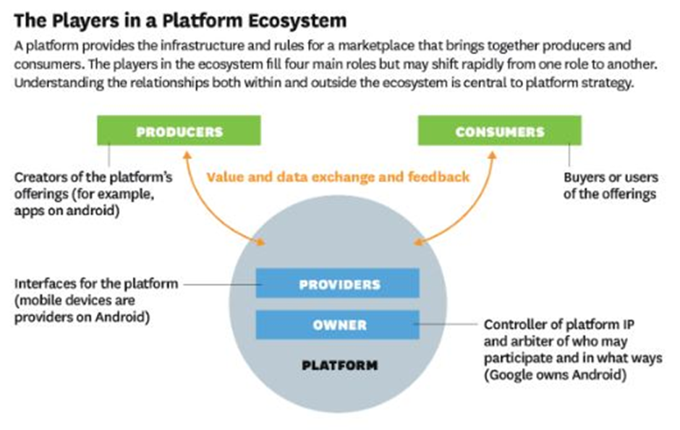

*(Source: HBR – The Players in a Platform Ecosystem – Marshall et. Al.)*

The platform we are developing here allows us to exchange values in the form of medical equipment. It is a marketplace for used or refurbished medical equipment. We have decided to name it as Med Market, as in Medical Market.

The platform strategy can be evaluated based on 4 key components.

**Value Proposition** – the unique value that Med Market provides to buyers (consumers) and sellers (producers) include the ease of finding a piece of medical equipment, cost savings offered by acquiring used or refurbished sets, insurance coverage to transactions on the platform, secondary market to sell used medical equipment, convenience of acquiring equipment, expertise of refurbishing medical equipment, certification, and trust of equipment. In the subsequent growth phase of our business model, we will include additional services to support community building on the platform.

**Revenue Model** – the revenue model of our Med Market is widely diversified into the following, such as commission-based (transaction) fees, subscription (membership) fees, and advertising fees. We will also be considering creating an E-Wallet feature for exchanges of value through our Med Market. As our users grow, we will put up a series of “Med Business”, for users of medical related services such as demand generation, medical sampling, brand influence, and building the medical related community for exchange of information amongst users of the platform. We will set up Tiered Memberships for consumers or users of the platform. For Premium Med Market Users, the members' fees will be higher, however the additional premium services like higher equipment discount, free door to door delivery, 30 days money back guarantees etc, generally justify the higher fees.

In our initial phase of growth, the share of the wallet of our revenue income will primarily be from commission-based (transaction) fees (% of sales of used or refurbished medical equipment) and advertising fees.

We will be charging a 10% commission-based (transaction) fee from both producer and consumer side, for all the medical equipment sold over our Med Market platform. Charging a transaction fee is the most common way for a platform to monetize, and it rarely decelerates the growth of the network effects since both sides are not charged before they accept to enter the deal. (Posthumus and Samson, 2018)

We will be analysing the probable Med Market advertising income as below. As it is very difficult to get reliable sources to gauge the size of advertising spending in Singapore. However, from Statista, we can see that the biggest market for advertisement spending in APAC in 2021 is China, at US$90.94 billion. We have India as the lowest in APAC at US$10.13 billion. I am putting in a conservative assumption, that Singapore's advertising market is only 10% of India, at approximately US$1 billion in 2021 and 2022.

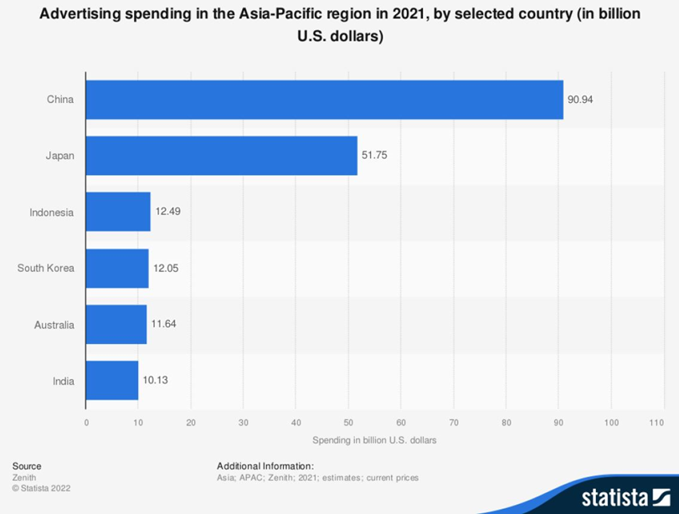  
  
Do note that the advertising market comprises both digital and non-digital means. The below stats show the % for digital ad spend share for Singapore.

Out of the approximate US$1 billion in advertising spending in Singapore in 2022, if Singapore’s digital advertising spend share is at 40.3% as above, we will have a Service Addressable Market of US$403 mil (40.3% of US$1 billion) in Singapore, for 2022. With a rough estimate at 0.05% of the SAM, the Service Obtainable Market (SOM) Med Market is targeted to achieve for the App Advertising Market in Singapore, will be US$0.2 mil or US$200K for the 2nd year onwards where we expand our product and services to used and new medical equipment and services.

As Med Market will be targeting a niche market of medical equipment and service providers, where marketing budgets may be more generous, we are confident of achieving the target of US$200K, mostly from medical equipment and medical supplies manufacturers.

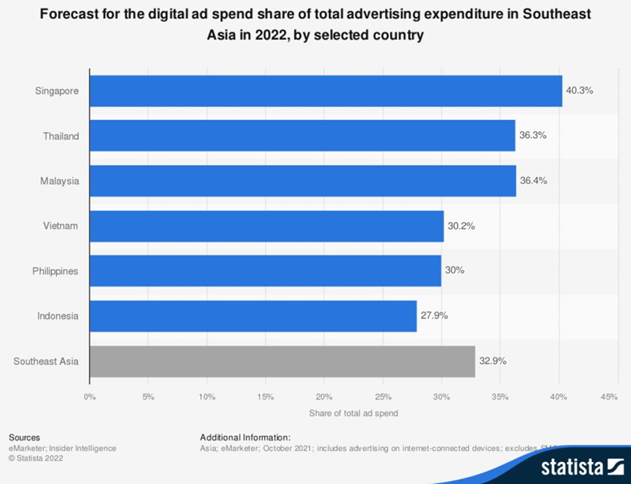

Bulk of the US$200K digital advertising dollar above, will be from Medical Equipment Manufacturers, targeting our customers or buyers who are looking to purchase refurbished units, and might be swayed to purchase new medical equipment with the latest features. Advertising Fees may also be from health supplement companies as well.

**Platform Design** – Med Market shall be easy to register, user-friendly, reliable, and secure. There will be advanced features such as AI search capabilities (through Videos, Pictures, Names etc), secure payment options, communication tools such as Chatbots, Messenger Chats with fellow users, Ask the experts Q&A features, and Med Market will work with logistic providing partners to ensure positive experiences on our platform. Med Market will also be qualified to meet all regulatory and ethical requirements in our business practices, in accordance with local regulations and laws.

**Growth Strategy** – As we are a platform business, our priorities are to attract and retain sellers and buyers onto the platform, as well as to facilitate interactions between consumers and producers. Growth strategies for Med Market are further elaborated as below.

**1. Expand user base** - This is done by attracting new buyers and sellers onto the platform. Buyers may be looking for different types of medical products and equipment, further extending to even newer and more competitively priced models. Buyers may also look at technologies from non-local markets, which have been tested and proven viable, as well as being peer-reviewed in our Med Market platform. Initial targeted sellers may be individuals with used medical equipment, however this seller base may be extended to many different types or range of medical equipment, from medical beds to N95 masks, as some examples.

**2. Expand product and service offerings** - By adding new features like online / real time chat, review ratings, E-wallet services, we can continue to attract users onto the platform. By extending the Med Market platform to include new medical equipment, new types, or range of medical equipment, as well as services such as Inventory and Storage, refurbishing services for equipment, we will be developing the ecosystem of Med Market.

In subsequent phases of growth, we will include Med Market Business Solutions such as “Medical Market Intelligence”, “Demand Generation for Medical Industry”, “Sampling for Health Supplements” and finally customised solutions for medical businesses.

**3. Expand to new geographical markets** - Med Market will be launched in Singapore, USA, and India. However due to similarities in market dynamics and demographics of potential users, Malaysia will be in our next geographical expansion plans, likely in the second half of the year. We will fuel our expansions to other subsequent Southeast Asian countries within the next 2 to 3 years. Likely further expansion to China, Australia, and Japan, within the 5th year of inception.

**4. Acquire complementary businesses** - Med Market will consider acquiring Business Analytics companies once we launch our Med Market Business Solutions. We will be able to offer professional and effective business analytics solutions for users on our platform. Acquiring physical companies like delivery services, inventory services may be considered as a complimentary growth strategy too.

**5. Partnership** - Med Market is open to partnership with businesses that will complement and align to our growth aspiration. In markets where we have gaps, we will consider partnerships as a growth strategy.

**6. Innovate** - Fundamentally, the most important growth strategy of any business, is to invest in research and development, and continue to innovate while being adaptable to the changing dynamics of the market. Developing new technologies, offering new products and services, investing in building the community and continually adding value into the ecosystem, can help to differentiate the platform from its competitors, and solve new challenges and needs.

What started out as an initial Transaction Ecosystem, Med Market platform strategy is to position ourselves for long-term success and growth, while providing value to all stakeholders in the ecosystem, ultimately becoming a Singapore Unicorn, and ultimately transitioning into a Solution Ecosystem where we invited complementors with complimentary products and services to integrate their offerings to enhance the overall value of the ecosystem.

**Minimal Viable Ecosystem**

Med Market is very focused on developing our minimal viable ecosystem, by focusing our core vision and mission, which is to connect people with needs to people with medical equipment. We want to establish a dense network of users and partners and over time, expand our value proposition to providing affiliated products and services.

From the business model canvas, stakeholder analysis and other analysis discussed above, Med Market is able to determine what is needed in a minimum viable ecosystem. (Gons, 2021). A minimum viable ecosystem (MVE), a term coined by Ron Adner in his book, The Wide Lens in 2012, focuses on a basic value proposition, which is to connect people with medical equipment needs and to reduce wastage. Over time, Med Market expanded its value proposition by introducing new products and services, as well as integration to partner applications to enhance the overall experience of Med Market platform.   
  
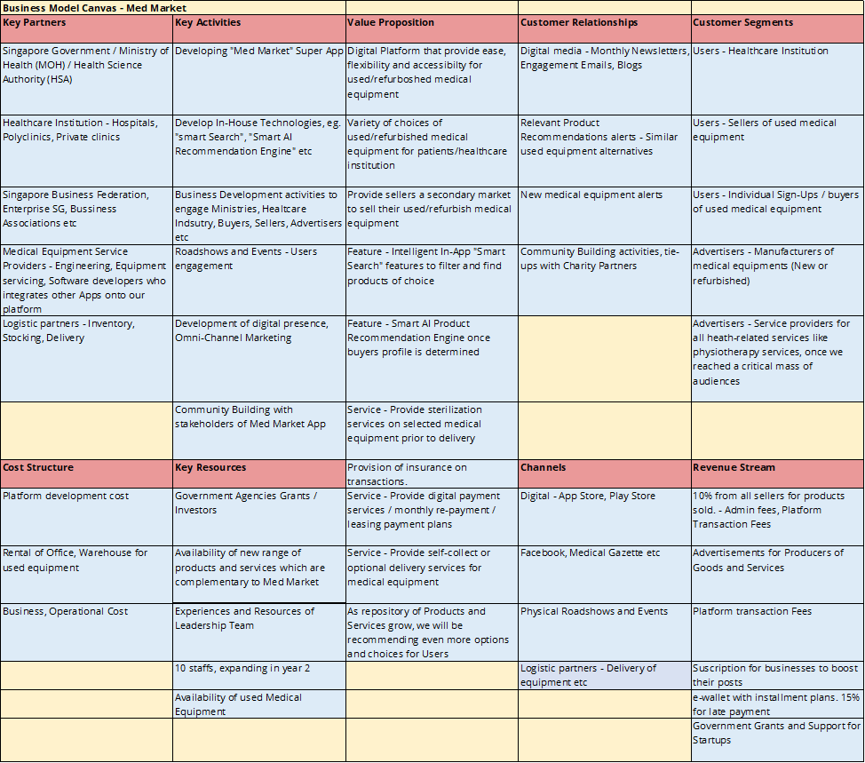

*(Source: MGT562 GBA Team - Med Market preliminary Business model canvas)*

In order to reduce the chance of failing, Med Market will be very focused on our core offering of matching used or refurbished medical equipment with needs of buyers who want to acquire competitively priced 2nd hand equipment. Me Market is also very careful not to stretch resources to expand to geographic areas beyond what we can manage. Singapore, USA, and India are our focused market, and then to the South-East Asian region due to land proximity. To enhance the ease of use of the platform, we will not be putting in additional products and services until we can achieve critical mass with our core offerings.

Med Market started out as a transaction ecosystem, we focused first on building supply, by using various ways like getting individuals or healthcare institutions to list their used or refurbished medical equipment for free. We make it very easy for them to list their items on our platform, and in some cases, we even offer to collect and deliver their equipment for free. We also allow these equipment providers to list their items for free for a limited time and reduce our commission fees for selected equipment. All these are focused on building the supply (producer) side of the market. Med Market also incentivises referrals to existing suppliers/sellers to bring in other sellers to the platform. Med Market actively marketed our offerings to build the demand side of the platform in parallel. These activities are focused on only one outcome, which is to attain critical mass as early as possible.  
  
As Med Market progresses further towards a solution ecosystem, we focus on convincing solution partners like logistics, engineering services and payment mechanisms to integrate to our Med Market platform. Some of our strategy is to acquire some of these partners or complementors if they enhance our total value proposition.

As Ulrich et al. puts it in his article, “How do you “Design” a Business Ecosystem?” (2020), launching a business ecosystem requires more than a concrete initial design. It also takes a great team, strong investors who believe, and reasonable patience to let the ecosystem gain traction. Med Market must also be mindful that there are lots of factors affecting the viability, thus there must be resolute focus on all factors that may affect the ecosystem and be able to evolve with the dynamics of the market.

**Financial Plan & Projection**

**Revenue & Profitability Projection**

In the initial 1-2 years of the business, it is expected for the business to rely on venture capitalists and government grant support to kickstart and sustain. Based on market cost to design an e-commerce app, the fees can range between US$60,000 to US$150,000 for an average complexity app (SPD LOAD, 2021). Coupled with the need to develop both variants of apps for Android and iOS, this will mean a total of US$300,000 at the upper cap. The initial years will be focused on growing the installed base, with reinvestment of all its revenues back into the business. The Med Market app will be free to download and create user accounts.

To solve the chicken and egg issue, we will have to maintain a side business offering sterilisation and refurbishment services as a complementary service at cost recovery prices, as well as provide insurance coverage on transactions made on the app. We assume this to cost approximately 1% of our total revenues (approx. US$10 million based on USS$1 billion projected revenue spread across 10 years), which will be taken care of by our monetisation strategies below. It is expected that as part of the growth strategy, that we will also invest approx. US$200 thousand on paid advertising to quickly ramp up the installed base. Assuming we obtain a reasonable percentage of 20-30% of the market share captured by year 1, we will proceed to offer paid product boosting services to sellers on a subscription basis, as well as the introduction of paid third-party advertisers to advertise on the app. The objective is to gain approximately 50% of market share. Key financial performance indicators to use can be the cost per user acquisition, user lifetime value, user account churn rates, number of products and user accounts on the app.

To summarise, based on the above, the initial total start-up cost of the business would be approx. US$1.5 million after factoring for app development cost, advertising costs, and complementary services. We assume the business would be self-sufficient beyond the initial start-up phase.

We have examined the different monetization strategies or revenue model of Med Market in the previous section. We have concluded that the three-revenue model we will adopt are commission-based (transaction) fees, subscription (membership) fees and advertisement-based fees. Based on how the value drivers are relative to each other, we have a summary table below (Kasper et al.,2019)  
  
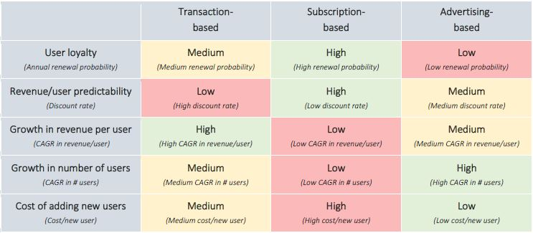  
  
(*Source: Kasper et al.,2019: Valuation of Digital Platforms)*

Form the table above, Med Market does not have a specific revenue model that is more profitable than the other, as it is also dependent on the life cycle of Med Market, what additional products and services it is offering as we scale the business, and which type of user growth on our Med Market platform. Therefore, we can determine that transaction-based platforms exhibit the greatest potential for revenue growth from existing users (both producers and consumers), membership fees tend to generate most predictable and sustainable growth, while advertising fees allows for most exponential growth in users.

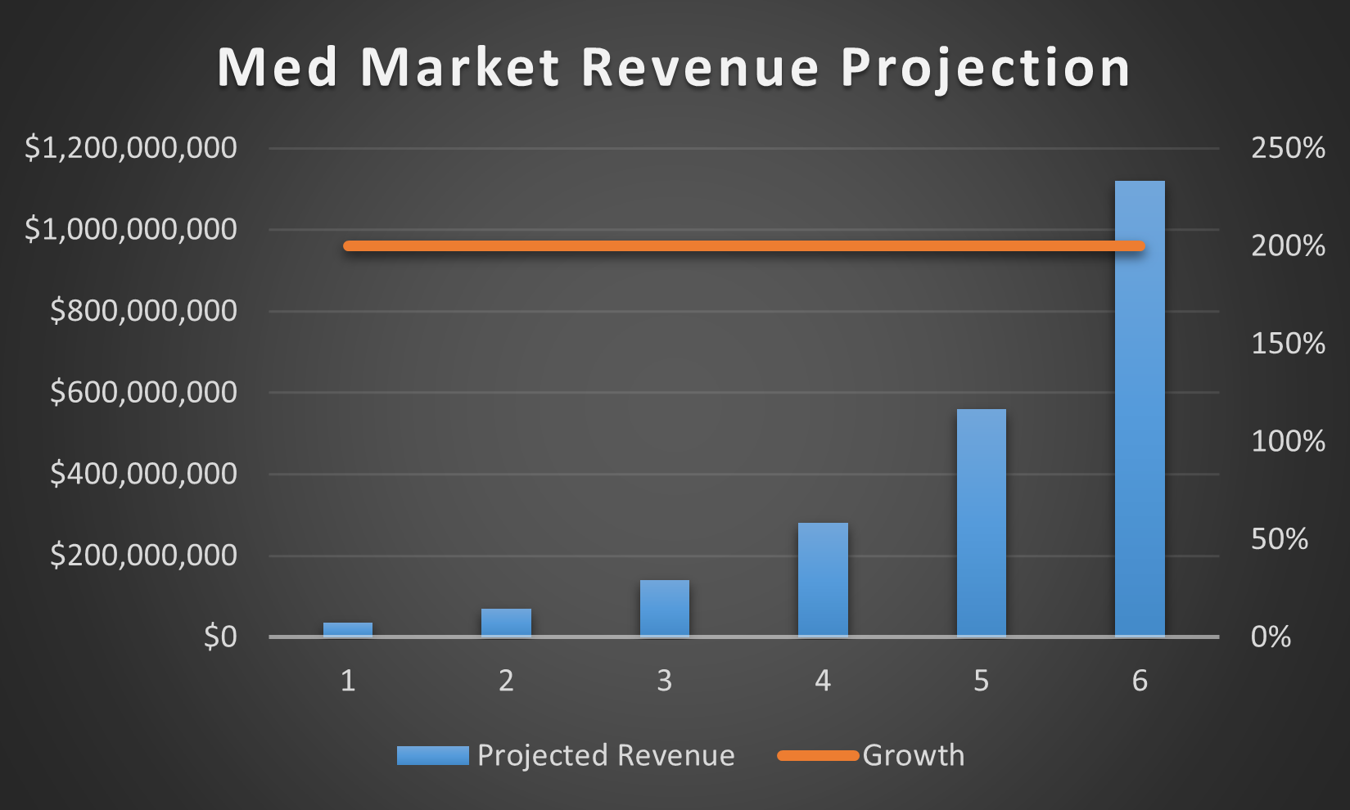

Assuming Med Market’s projected revenue is SGD 35 million in the first year, from the various core revenue streams of transaction fees, membership fees and advertising fees combined, and growing at a 200% YOY, Med Market will reach a revenue of SGD 1,120,000,000 by year 6.

We are putting in assumptions that we have a subscription or membership number of 10,000 by the first year @ $100 of paid fees (SGD 1 mil), coupled with SGD 50 mil worth of transactions in year 1. If we charge 10% as our Med Market transaction fees, we will generate SGD 5 mil worth of revenue. Finally, we have projections of SGD 29 mil coming in from advertisements alone, making a total of SGD 35 mil of projected revenue in year 1.

|  |  |  |
| --- | --- | --- |
| Year | Projected Revenue | Growth |
| 1 | $35,000,000 | 200% |
| 2 | $70,000,000 | 200% |
| 3 | $140,000,000 | 200% |
| 4 | $280,000,000 | 200% |
| 5 | $560,000,000 | 200% |
| 6 | $1,120,000,000 | 200% |

200% growth Year-on-Year (YOY) growth is achieved by putting up new medical products like high value equipment such as refurbished CT scan etc, or other products such as Health Supplements, as well as new services like providing a platform for nursing services, telemedicine, ambulance services or any health-related services. All these complementary new products and services will fuel Med Market growth towards a unicorn status.

**Valuation**

Business valuation is the process of determining the economic value of a business. There are various methods to do a company valuation, and the most used ones are:

1. Comparable company analysis (CCA) which involves comparing the company being valued with similar publicly traded companies. The valuation is based on the market multiples of these comparable companies, such as price-to-earnings (P/E) ratio, price-to-sales (P/S) ratio, or enterprise value-to-EBITDA (EV/EBITDA) ratio.
2. Discounted cash flow (DCF) involves estimating the future cash flows of the company and discounting them back to their present value. The valuation is based on the net present value (NPV) of the estimated cash flows.
3. Asset-based valuation quantifies the company's assets, such as property, plant, and equipment (PP&E), inventory, and intellectual property, and subtracting its liabilities to arrive at the company's net asset value.
4. Earnings multiple involves valuing the company based on its earnings, such as earnings before interest, taxes, depreciation, and amortization (EBITDA). The valuation is based on a multiple of the company's earnings.

The valuation process allows us to know the worth of Med Market by analysing all components of the business, including company’s management, capital structure, future earnings, and market value of assets. As a platform-based business that is asset light, it is likely that the primary value of the business will be based on the market captured and installed base.

As per our revenue projection above, we are putting in assumption that we will attain our SGD1bil Unicorn target in terms of revenue in year 6. We also understand that our business model and growth may stagnate once the market saturates, and we should not expect a 100% growth in revenue after year 6. While we are putting in a conservation estimate of 10%-20% growth YOY from year 6 onwards, we will still be expecting a yearly value of above SGD1bil. As such, we will expect a market value of SGD1bil from year 6 onwards, while we continue to innovate and pull in a new revenue model.

The choice of valuation method depends on the company's industry, stage of development, financial performance, and other factors. It's essential to use multiple methods to validate the valuation and arrive at a reasonable estimate of the company's value. It's also important to consider the qualitative factors, such as the company's management team, brand reputation, competitive landscape, and market trends.

By utilising the discounted cash flow (DCF) analysis and assuming a 10-year horizon for the DCF analysis, we can estimate the future cash flows of Med Market based on the projected revenue and expenses. Assuming a 25% discount rate, which accounts for the high risk and uncertainty of a startup, we can discount the future cash flows back to their present value.

Using the projected revenue and expenses stated above, we can estimate the following cash flows for years 1-10:

Year 1: SGD 35 million

Year 2: SGD 70 million

Year 3: SGD 140 million

Year 4: SGD 280 million

Year 5: SGD 560 million

Year 6: SGD 1,120 million

Year 7: SGD 2,240 million

Year 8: SGD 4,480 million

Year 9: SGD 8,960 million

Year 10: SGD 17,920 million

The sum of the present value of these cash flows is the estimated enterprise value of the company before accounting for debt and cash balances. Assuming a conservative multiple of 5x the enterprise value, we can estimate the company's valuation as follows:

Valuation = 5 x Present Value of Cash Flows

Valuation = 5 x SGD 1.675 billion

Valuation = SGD 8.375 billion

Therefore, based on the assumptions and projections stated above, Med Market's estimated valuation would be SGD 8.375 billion in 10 years' time.

However, once the market saturates, it’s important to consider complementary services as the next step to scale and to continue generating profits. Further by incorporating advanced emerging technologies could scale the profit. These services and technological advancement could also help differentiate Med Market from its competitors and position it as a leader in the healthcare industry.

# References

Auto, H. (2022, September 21). *Cheaper drugs at GPs under Healthier SG “one resident, one doctor” scheme to be launched in 2023 | The Straits Times*. Www.straitstimes.com. <https://www.straitstimes.com/singapore/health/cheaper-gp-visits-under-healthier-sg-one-resident-one-doctor-scheme-to-be-launched-in-2023>

Bimedis. (n.d.). *Marketplace for new and used medical equipment and hospital equipment*. Bimedis. <https://bimedis.com/>

Carlos Carrasco, Yuliya Snihur, Pascual Berrone, Joan Enric Ricart (2022). The stakeholder value proposition of digital platforms in an urban ecosystem. *Elsevier Research Policy, Volume 51, Issue 4, 104488.* doi.org/10.1016/j.respol.2022.104488

Concepta. (n.d.). *The Dos and Don’ts of Scalable ArchitectureSoftware Engineering*. [Www.conceptatech.com](http://Www.conceptatech.com). <https://www.conceptatech.com/blog/dos-donts-designing-scalable-architecture>

D M Dickey. *Clinical engineering helps reduce equipment costs*, <https://pubmed.ncbi.nlm.nih.gov/10145094/>

Deloitte Consulting. (2019). *The Silver Avalanche Are you prepared?* <https://www2.deloitte.com/content/dam/Deloitte/sg/Documents/strategy/sea-so-monitor-deloitte-the-silver-avalanche.pdf>

Edosa Tesfaye Geta,1 Dufera Rikitu Terefa,1 and Adisu Ewunetu Desisa1. *Efficiency of Medical Equipment Utilization and Its Associated Factors at Public Referral Hospitals in East Wollega Zone, Oromia Regional State, Ethiopia*, https://www.ncbi.nlm.nih.gov/pmc/articles/PMC9968427/.

Facebook. (n.d.). *Caregivers for Elderly | Facebook*. Www.facebook.com. Retrieved April 12, 2023, from <https://www.facebook.com/groups/CaregiversSupportGroupSG/buy_sell_discussion>

Feng Shen, editor. *Identifying and Predicting Healthcare Waste Management Costs for an Optimal Sustainable Management System: Evidence from the Greek Public Sector*, 2022, https://www.ncbi.nlm.nih.gov/pmc/articles/PMC9408452/.

Gons, E. (2021, December 9). *Kickstart corporate innovation by building a Minimum Viable  
Ecosystem*. Retrieved from Ground Control: https://togroundcontrol.com/blog/kickstart-cocorporate-innovation-by-building-a-minimum-viable-ecosystem

Hagiu, A., & Rothman, S. (2018, February 9). *Network Effects Aren’t Enough*. Harvard Business Review. <https://hbr.org/2016/04/network-effects-arent-enough>

Hinrichs-Krapels, S., Ditewig, B., Boulding, H., Chalkidou, A., Erskine, J., & Shokraneh, F. (2022). Purchasing high-cost medical devices and equipment in hospitals: a systematic review. *BMJ open, 12*(9), e057516. Retrieved from https://bmjopen.bmj.com/content/12/9/e057516

Hintze, H. (2020, Nov 10). *Palmer nonprofit working on warehouse to store used medical equipment*. Retrieved from Alaska's News Source: <https://www.alaskasnewssource.com/2020/11/10/palmer-nonprofit-working-on-warehouse-to-store-used-medical-equipment/>

Kasper Tengel Hessellund et al,. (2019, May 15). *Valuation of Digital Platforms - Valuing companies with negative profits and millions of users*

Malhotra, R., Bautista, M. A., Müller, A. M., Aw, S., Koh, G. C., Theng, Y.-L., . . . Chan, A. (2019, June). The Aging of a Young Nation: Population Aging in Singapore. *The Gerontologist, 59*(3), 401 - 410. doi:10.1093/geront/gny160

Marshall W. Van Alstyne, G. G. (2016, April). *Pipelines, Platforms, and the New Rules of Strategy*.  
Retrieved from Harvard Business Review: https://hbr.org/2016/04/pipelines-platforms-and-the-new-rules-of-strategy

Medina, A. F. (2022, October 21). *Singapore Introduces New Healthcare Reform Plan*. ASEAN Business News. <https://www.aseanbriefing.com/news/singapore-introduces-new-healthcare-reform-plan/>

Meticulous Research. (2023, Feb 23). *Latin America Home Healthcare Market Worth $37.15 billion by 2030 - Market Size, Share, Forecasts, & Trends Analysis Report with COVID-19 Impact*. Retrieved from Yahoo Finance: https://finance.yahoo.com/news/latin-america-home-healthcare-market-150100364.html; https://www.meticulousresearch.com/product/latin-america-home-healthcare-market-1287?utm_source=PRnewswire&utm_medium=Paid&utm_campaign=Product&utm_content=23-02-2023#desc

Mirza, A. (2017, Mar 9). *Hospitals Waste Billions of Dollars in Medical Supplies*. Retrieved from U.S. News: <https://www.usnews.com/news/healthcare-of-tomorrow/articles/2017-03-09/hospitals-are-wasting-billions-of-dollars-worth-of-medical-equipment>

NAM. “Access to Medical Devices in Low-Income Countries: Addressing Sustainability Challenges in Medical Device Donations.” *National Academy of Medicine*, 16 July 2018, https://nam.edu/access-to-medical-devices-in-low-income-countries-addressing-sustainability-challenges-in-medical-device-donations/. Accessed 18 April 2023.

Ng, K. (2015, Dec 2). *Help for low-income families to rent electric homecare beds*. Retrieved from Today Online: <https://www.todayonline.com/singapore/help-low-income-families-rent-electric-homecare-beds>

Posthumus, T., Samson, S. (2018). How to monetize a platform. *KPMG*

Rajendra Singh, P. M. (2023, Jan 31). *Hospital Beds Market is expected to surpass revenues worth US$ 5.91 Billion between 2023 and 2032 at a CAGR of 5.7%*. Retrieved from Yahoo Finance: <https://finance.yahoo.com/news/hospital-beds-market-expected-surpass-133000647.html?guccounter=1&guce_referrer=aHR0cHM6Ly93d3cuZ29vZ2xlLmNvbS8&guce_referrer_sig=AQAAAAM556KcV2qQzuMlF8-9ENXNohleUkvNcJPuuTEP5s3DdhjKbVpN0g8YaMy3ND7gRfyFE2K2B5GRemXNpe7ZtIKUkb>

Ron Adner, (2013). *The Wide Lens.* Publisher Penguin Books

Segar, V., Ang, P. K., Foteff, C., & Ng, K. (2021). A review of implementation frameworks to operationalize health technology assessment recommendations for medical technologies in the Singapore setting. *International journal of technology assessment in health care, 37*(1), e56. doi:10.1017/S0266462321000222

Shawi, M. A. (2020, November 3). *Architecting for Reliable Scalability*. Amazon Web Services. <https://aws.amazon.com/blogs/architecture/architecting-for-reliable-scalability/>

SPD LOAD. (2021, September 16). App Development Cost in 2021 by App Type (& Examples). SPDLoad. <https://spdload.com/blog/app-development-cost/>

Statcounter. (2023a). Mobile Operating System Market Share Singapore | StatCounter Global Stats. StatCounter Global Stats. https://gs.statcounter.com/os-market-share/mobile/singapore

Statcounter. (2023b). Mobile Operating System Market Share United States Of America | StatCounter Global Stats. StatCounter Global Stats. https://gs.statcounter.com/os-market-share/mobile/united-states-of-america

Statista. (2023). India - mobile OS share 2019 | Statista. Statista; Statista. <https://www.statista.com/statistics/262157/market-share-held-by-mobile-operating-systems-in-india/>

Statistics Singapore. (n.d.). *Births and Fertility*. Retrieved from Department of Statistics Singapore: https://www.singstat.gov.sg/find-data/search-by-theme/population/births-and-fertility/latest-data

Statistics Singapore. (n.d.). *Death and Life Expectancy*. Retrieved from Department of Statistics Singapore: https://www.singstat.gov.sg/find-data/search-by-theme/population/death-and-life-expectancy/latest-data

STENGLE, J. (2022, Sep 10). *Donating late son’s medical equipment brings mother solace*. Retrieved from AP News: <https://apnews.com/article/technology-health-philanthropy-san-antonio-medical-equipment-8311bb7689e97db9f93dc1fb503dc23d>

Tan, K. (2022, July 6). *Commentary: Singapore’s ageing population does not only bring challenges*. CNA. <https://www.channelnewsasia.com/commentary/singapore-ageing-population-longevity-economy-opportunity-challenge-2790051>

Ulrich Pidun et al. (2020). *How do you “Design” a Business Ecosystem?* Retrieved from BGC:   
<https://bcg.com/publications/2020/how-do-you-design-a-business-ecosystem>

Van Alstyne, M. W., Parker, G. G., & Choudary, S. P. (2017, March 21). *Pipelines, Platforms, and the New Rules of Strategy*. Harvard Business Review. <https://hbr.org/2016/04/pipelines-platforms-and-the-new-rules-of-strategy>

WHO. “Medical devices: an area of great promise.” *World Health Organization (WHO)*, 9 September 2010, https://www.who.int/director-general/speeches/detail/medical-devices-an-area-of-great-promise. Accessed 18 April 2023.

“Artificial Intelligence and Machine Learning Based Intervention in Medical Infrastructure: A Review and Future Trends.” *NCBI*, 10 January 2023, https://www.ncbi.nlm.nih.gov/pmc/articles/PMC9859198/. Accessed 18 April 2023.

“The use of Big Data Analytics in healthcare.” *NCBI*, https://www.ncbi.nlm.nih.gov/pmc/articles/PMC8733917/. Accessed 18 April 2023.